BUNNYRABBIT.com CONDO Cage Instructions
- Stand up connected pieces with bent side pieces on the bottom.
- Attach top wire (1”x2”x24”x24”). Placing a c-ring every 3”.
- Attach bottom floor (1/2”x1”x24”x24” ) 28” from top. Attach a c-ring every 2”.
- Attach middle floor (1/2”x1”x24x24” with 6”x8” hole) 14” from top with 6”x8” hole in rear of cage on the right. Place c-ring every 2”.
- Attach loft. Fold the side up and attach to the top of the cage 12” from the rear.
- Attach loft ramp to loft and middle floor.
- Attach bottom ramp to right side of 6”x8” hole in middle floor and 4” from left side of cage to bottom floor.
- Attach front with door latches up so door opens down. Attach at top, sides, middle floor and bottom floor.
- Slide pan under bottom floor.
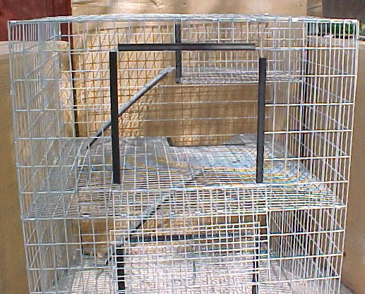
- Put your rabbit in the cage and watch him explore
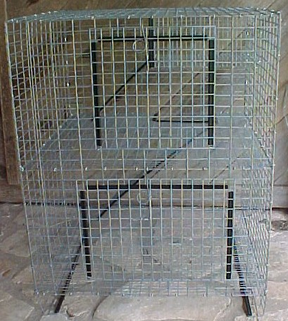

Courtesy of BUNNYRABBIT.com
Instructions: http://www.bunnyrabbit.com/price/petcagecombo.htm
email: bunnies@bunnyrabbit.com

